Geometry: Unit 6, Lesson 10
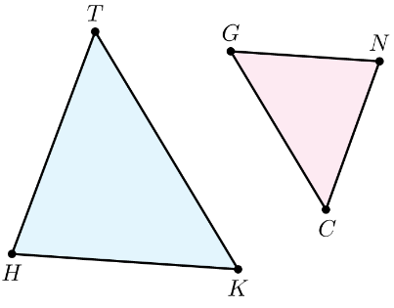
- Triangles $CGN$ and $HKT$ are shown. $∆CGN\sim ∆TKH$. What corresponds to $\overline{CG}$?

$$\overline{TK}$$

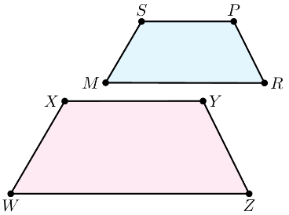
- Quadrilaterals $WXYZ$ and $MSPR$ are shown. If $WXYZ \sim MSPR$, then what is proportional?

Corresponding Sides

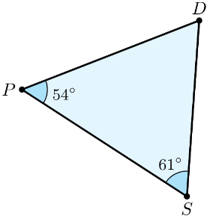
- Triangle $DSP$ is shown. What is the measurement of angle $D$?

$$65°$$

